Creating Custom List of Values Source for Scheduled Jobs

Introduction

I hope that most of you know how to create a “Custom ESS Job in Oracle HCM Cloud Application” and one limitation at that point of time was that we were not able to create custom list of value source and attach them with ESS job parameters. However, in the latest release (Release 13 19D) we do have the flexibility to attach a custom list of value source to ESS job parameter. The custom list of value source is based on a custom SQL (should not contain any bind variables).

In this example, we would demonstrate the same.

Pre-requisite

We should have a custom ESS Job available which should not have any list of value source attached to its parameter.

For this example, we will use a custom ESS Job titled “Get Employee Absence Plan Balance”.

We would try to submit this ESS

***Navigation-> Tools -> Scheduled Processes -> Search (Get Employee Absence Plan Balance)***

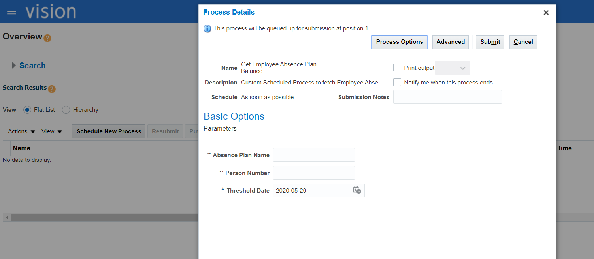

From the above screenshot we can clearly see that all the parameters are of “Text Box” type and there is no drop-down option to choose from.

We would now create two custom list of value source for “Absence Plan Name” and “Person Number”.

***Navigation: Setup and Maintenance -> Manage Enterprise Scheduler Job Definitions and Job Sets for Human Capital Management and Related Applications-> Manage List of Values Sources->Create***

|  |  |
| --- | --- |
| **Attribute Name** | **Attribute Value** |
| *Application Name | Absence Management |
| User List of Values Source Name | EmployeePersonNumber |
| Description | Custom List of Values Source To Display Person Number for All Employees Enrolled in Absence Plan |
| LOVType | User Defined |
| Query | SELECT peo.person_number  FROM per_all_people_f peo,  per_assignment_status_types_vl pastv,  anc_per_plan_enrollment appe,  per_all_assignments_f asg,per_periods_of_service ser,per_person_types_tl per_typ, anc_absence_plans_f_tl aapft, anc_absence_plans_f aapf  WHERE asg.person_id = peo.person_id  AND asg.assignment_status_type_id = pastv.assignment_status_type_id  AND peo.person_id = appe.person_id  AND appe.per_plan_enrt_id =(SELECT MAX(appe1.per_plan_enrt_id) FROM anc_per_plan_enrollment appe1  WHERE appe1.person_id = peo.person_id)  AND ser.period_of_service_id = appe.prd_of_svc_id  AND appe.plan_id = aapft.absence_plan_id  AND ser.person_id = peo.person_id  AND asg.period_of_service_id = ser.period_of_service_id  AND asg.person_type_id = per_typ.person_type_id  AND aapft.absence_plan_id = aapf.absence_plan_id  AND asg.primary_flag = 'Y'  AND asg.assignment_type IN ('E', 'C', 'N', 'P')  AND asg.assignment_status_type = 'ACTIVE'  AND per_typ.LANGUAGE = USERENV ('LANG')  AND aapf.plan_status = 'A'  AND aapft.LANGUAGE = 'US'  AND TRUNC (SYSDATE) BETWEEN peo.effective_start_date AND peo.effective_end_date  AND TRUNC (SYSDATE) BETWEEN asg.effective_start_date AND asg.effective_end_date  AND TRUNC (SYSDATE) BETWEEN aapf.effective_start_date AND aapf.effective_end_date  AND TRUNC (SYSDATE) BETWEEN aapft.effective_start_date AND aapft.effective_end_date  order by peo.person_number asc |

Application Screenshot

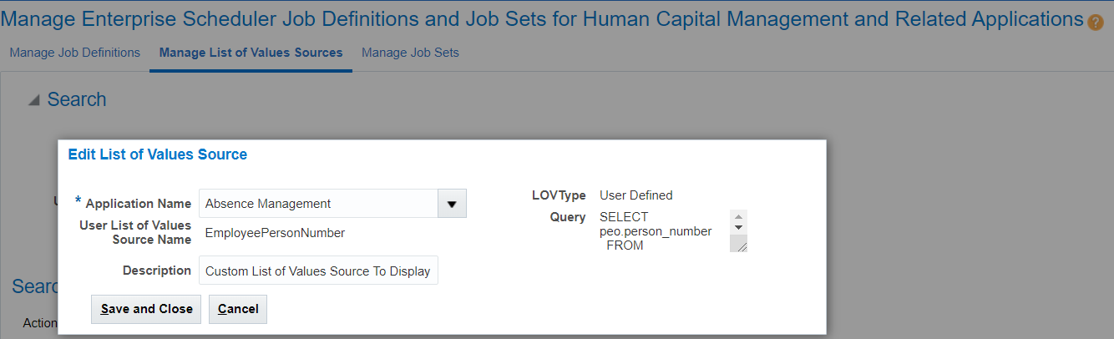

Similarly we need to create one more List of value for ***Absence Plan Name***

|  |  |
| --- | --- |
| **Attribute Name** | **Attribute Value** |
| *Application Name | Absence Management |
| User List of Values Source Name | LeavePlanName |
| Description | Custom List of Values to Display All Absence (Leave) Plan Names where employees are enrolled |
| LOVType | User Defined |
| Query | select aapft.name absenceplanname  from anc_absence_plans_f_tl aapft,  anc_absence_plans_f aapf  where aapf.absence_plan_id = aapft.absence_plan_id  and aapf.plan_status = 'A'  and aapft.language = 'US'  and trunc(sysdate) between aapft.effective_start_date and aapft.effective_end_date  and trunc(sysdate) between aapf.effective_start_date and aapf.effective_end_date  order by aapft.name asc |

Application Screenshot

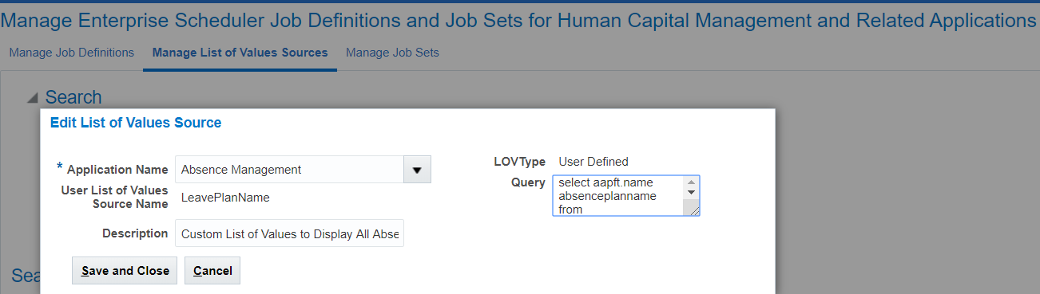

Attaching List of Values to ESS Job Parameter

We would need to associate the newly created List of value source to the ess job parameters.

Navigation: ***Setup and Maintenance-> Search for Task (Manage Enterprise Scheduler Job Definitions for Human Capital Management and Related Applications) -> Search for ESS Job (Get Employee Absence Plan Balance)***

Search for Absence Plan Name and associate LeavePlanBalance List of Value

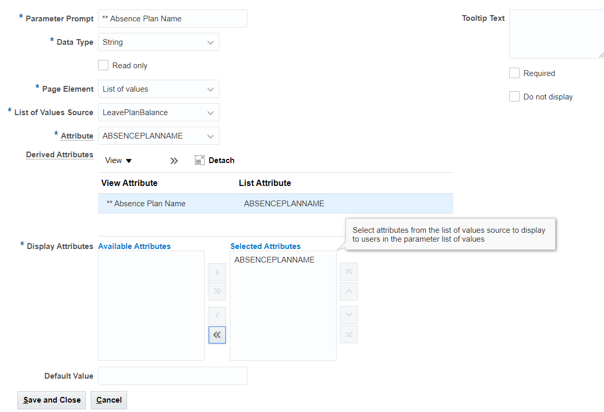

Similarly we would need to attach EmployeePersonNumber List of Value Source to Person Number ESS Job parameter

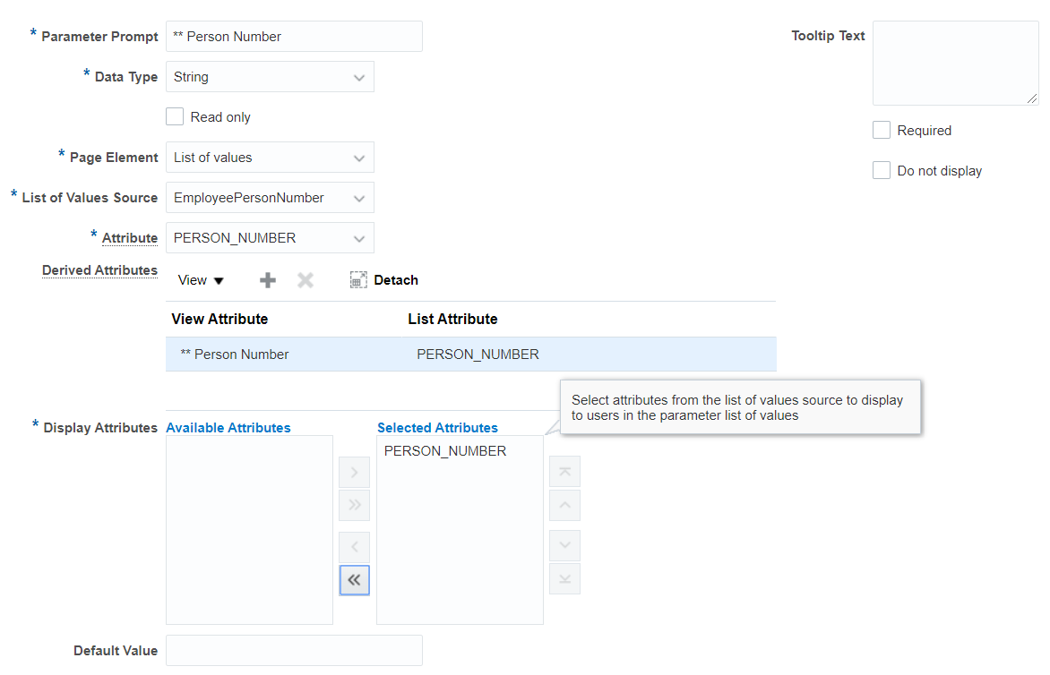

We are now done with the changes.

Verifying Results

As a last step we will run the ESS Job and check if the changes have reflected

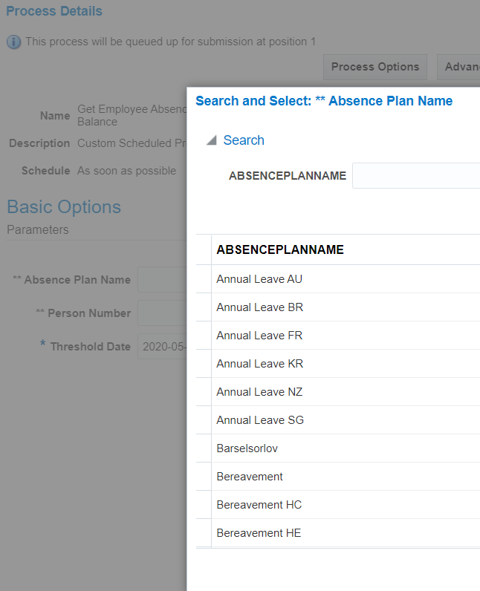

We would choose “Sick” as AbsencePlanName value

Similarly, we would need to choose a value for ***Person Number***

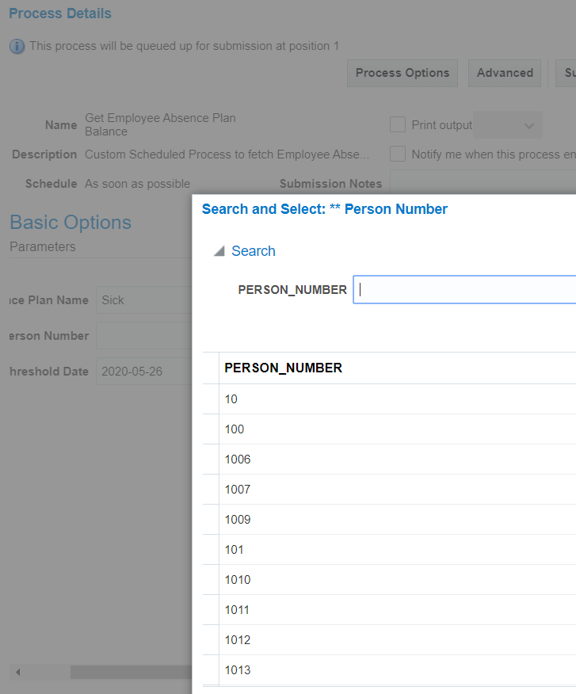

We would choose the value of 40 for this example.

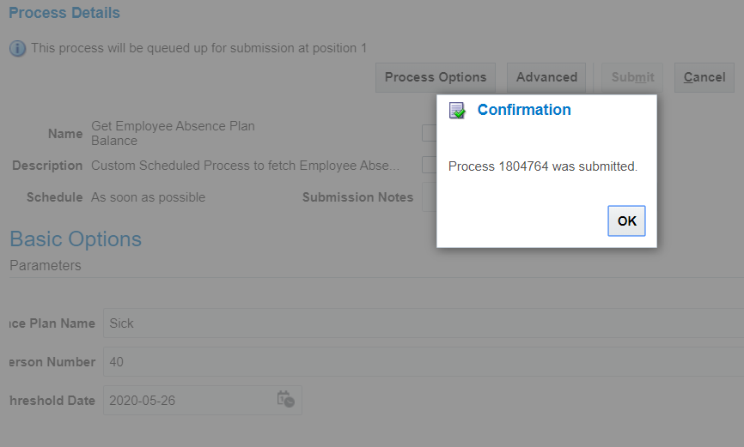

Output

Once the ESS job completes we can verify the output.

